MINI PROJECT

Raw Dataset URL: https://excelx.com/practice-data/sales-retail/

Excel Sheet Cleaned Drive Link:

Power Bi Dashboard Drive Link:

GitHub Link:

Report of the Project: -
- Data Pre-Processing Using Excel:
Cleaned the raw Dataset, changed Datatypes, did imputation for ‘Promotion’ column, as there were null values. Also, created a Pivot Table named ‘EACH SALESPERSON'S SALES QUANTITY & AMOUNT’ in a new sheet.

- Data Visualization using Power Bi:-
Imported the main cleaned table and pivot table into the Powery Query Editor, removed the unimputed ‘promotion’ column, and also transformed pivot table, made first row as headers.

DASHBOARD PRODUCT-SALES PERFORMANCE (2023-2025)

The Dashboard shows the overall performance of the sales of the products from 2023-2025, in each region, using different visuals like card, charts, tables, slicer, etc.

Data Modelling:
Created a Relationship ‘Many to One’ between the two tables called ‘Cleaned Dataset’ & ‘Pivot Table’ by a column named ‘Salesperson’, to enable visualizations.
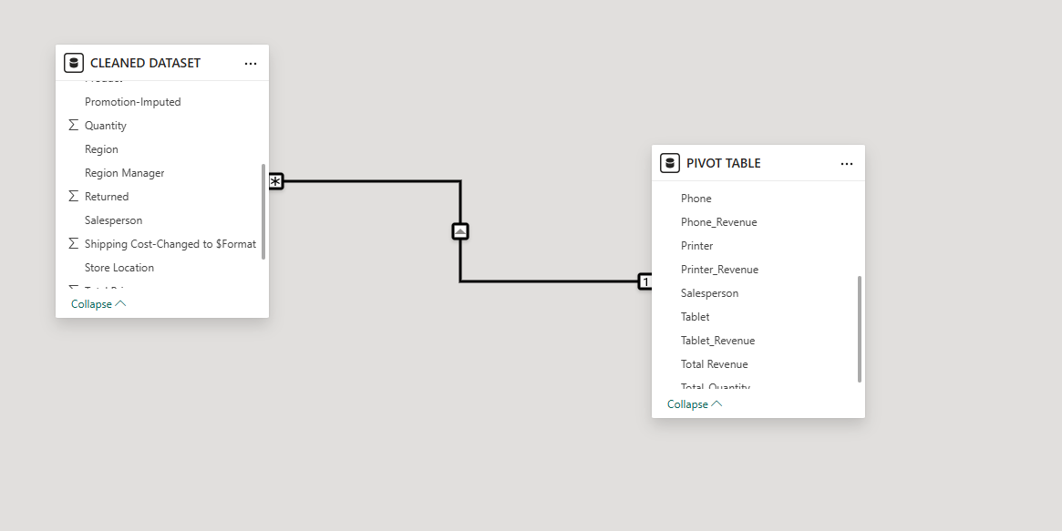

From Cleaned Dataset Table:
- Created a card ‘Total Revenue’ , a column chart called ‘Revenue by each region Manager’
- a line and stacked column chart called ‘Product-Sales Year-wise & Region-wise’ to showcase the revenue of each product in each year and each region and its trend.
- Also, created a Pie chart called ’Regional Analysis of Sales’
- And a Slicer called ‘Region Selection Slicer’ to slice and view all details Region-wise.
- Created a New Measure called ‘Rank of Sales Region-wise’ using a DAX function as below:
- Rank_Sales= RankX(All(CleanedDataset[Region], calculate(Sum(CleanedDataset[TotalPrice])),, Desc)
From Pivot Table:
- Created a Table called ‘Salesperson’s Revenue & Quantity sold’ to showcase the total revenue and total quantity sold by each salesperson.

Product-Sales Performance (2023-2025) Dashboard
